horizontal line

**Computer Vision**

Stereo Vision

**30th May 2021**

| **Name** | **ID** |
| --- | --- |
| **Jamal Eldin Ahmed Khalaf** | **15** |
| **Yomna Gamal El-Din Mahmoud** | **63** |

# Problem Statement

We implement and test some simple stereo algorithms. In each case you will take two images Il and Ir (a left and a right image) and compute the horizontal disparity (ie., shift) of pixels along each scanline. This is the so-called baseline stereo case, where the images are taken with a forward-facing camera, and the translation between cameras is along the horizontal axis.

# Block Matching

## Sum of Absolute Differences (SAD)

Get the disparity value at each point in the left image, by searching over a range of disparities, and compare the windows using Sum of Absolute Differences (SAD).

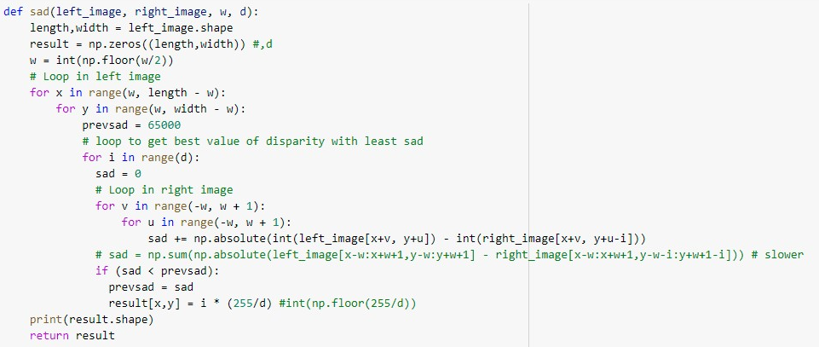

## Sum of Squared Differences (SSD)

Get the disparity value at each point in the left image, by searching over a range of disparities, and compare the windows using Sum of Squared Differences (SSD).

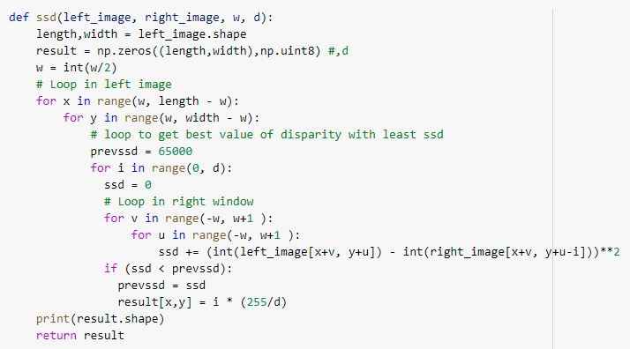

## Results

Left   
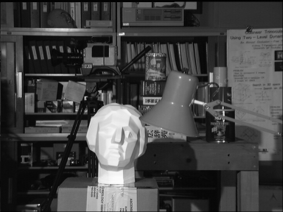

Right   
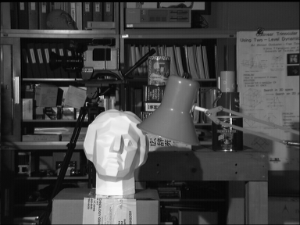

**SAD**

W = 1  
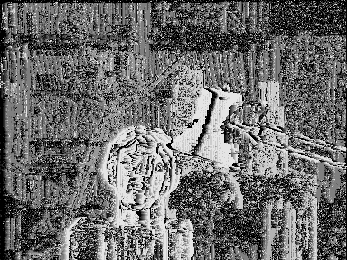  
W = 5  
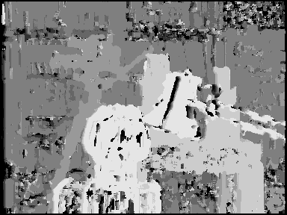

W = 9  


**SSD**

W = 1  
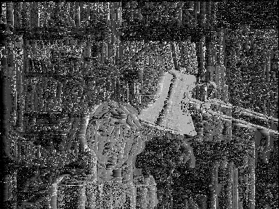  
W = 5  
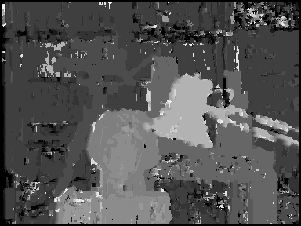

W = 9  
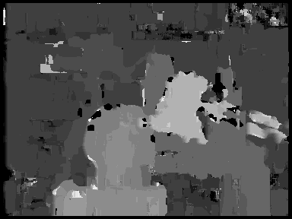

# Dynamic programming

Getting disparity matrix with DP algorithm as illustrated in assignment pdf.

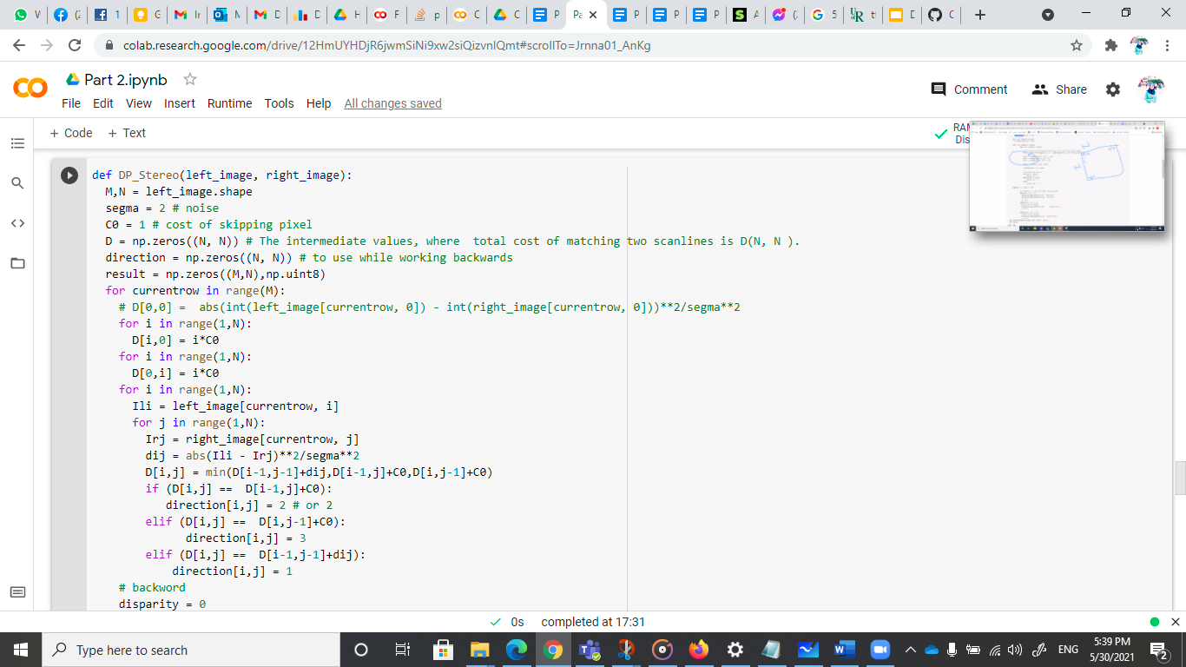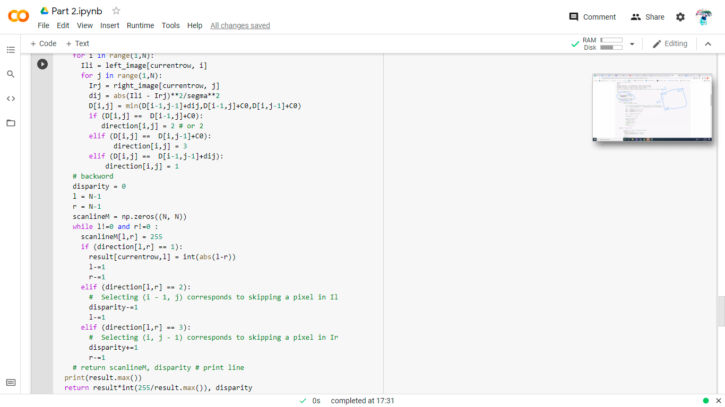

## Results

Left and right scanline



Example 1

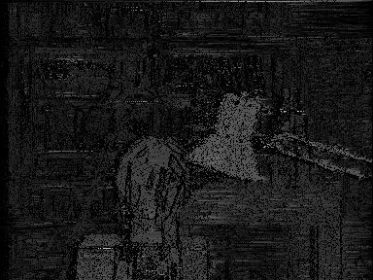

Example 2

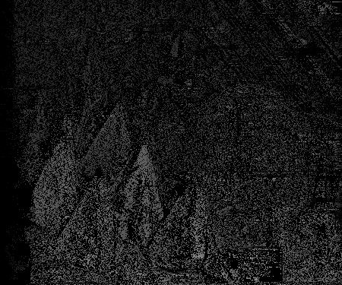

Example 3

